Reverse Brayton Cycle/Bell Coleman Cycle

# Introduction

A reverse Brayton cycle also known as Bell Coleman cycle (air as the medium), is a thermodynamic cycle that works on the same principle as Brayton cycle but in reverse. While the Brayton cycle is used to generate power, the reverse Brayton cycle is employed in cooling applications. It focusses on extracting heat from a cooler area and moving it to a warmer one, making it ideal for refrigeration and air conditioning systems.

Stages of the cycle:

1. **Isentropic Compression**: In this stage, a compressor is used to compress a low temperature, low pressure gas to higher pressure thereby increasing its temperature.
2. **Isobaric Heat Rejection**: In this stage, a condenser which is a form of heat exchanger releases heat from the high-pressure gas to the environment, cooling down to a lower temperature while remaining at high pressure.
3. **Isentropic expansion**: The cooled gas is now expanded through a turbine, thereby lowering the pressure and temperature, with a resultant net out from the Turbine.
4. **Isobaric heat absorption**: An evaporator is used The cold gas absorbs heat from the area being cooled, reducing the temperature in that space. The process occurs at constant pressure, and the gas as a result has a higher temperature.

Applications:

* Aircraft Air Conditioning: Commercial aircrafts use reverse Brayton cycles to cool their cabins, utilizing the compressed air from the engine's compressor (Compressor bleed).
* Industrial gas liquefaction: Reverse Brayton cycles are essential in the process of liquefying natural gas, such as LNG which is transported and stored more efficiently in its liquid state. Nitrogen is used as a refrigerant.
* Industrial Refrigeration: These cycles can be used in various industrial applications, such as food processing and chemical manufacturing, where refrigeration is required.

Assumptions

1. The turbine and compressor processes are isentropic
2. There are no pressure drops through the heat exchangers
3. The working fluid is modelled as an ideal gas.

Additional Considerations:

* **Real Gas Effects**: For more accurate modeling, consider using real gas equations of state (e.g., Peng-Robinson, Soave-Redlich-Kwong) to account for deviations from ideal gas behavior, especially at high pressures and low temperatures.
* **Component Losses**: Include losses due to friction, heat transfer to the surroundings, and other inefficiencies in the components (compressor, turbine, heat exchangers) to obtain a more realistic representation of the cycle.

**Variations:**

While this is a basic representation, the actual curves can vary depending on factors such as:

* **Working fluid**: Different fluids have different properties, which can affect the shape of the curves.
* **Component efficiency**: The efficiency of the compressor and turbine can influence the slopes of the isentropic processes.
* **Recuperation HX:** A cross flow heat exchanger can be employed for heat transfer from the gas exiting the condenser to the gas coming out from the evaporator.

**Draft**

Conditions:

* Ideal cycle under consideration

Ideal Gas equation of state

Pv = RT

Constant pressure cooling in Condenser:

Qout = Cp * (T2 - T3)

Constant pressure heat absorption:

Qin = Cp*( T1-T4)

Coefficient of performance of Reverse Brayton cycle:

Went = (h2-h3) – (h1-h4)

Cop = Qin/Wnet = ( h2-h3 ) – ( h1-h4)

Parameters required to calculate:

1. Specific heat ratio
2. Source and sink temperature

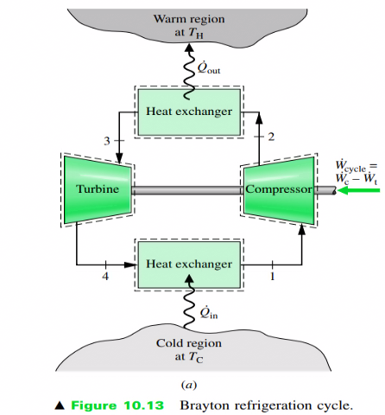

Sources: Fundamentals of Engineering Thermodynamics by Michael J.Moran Howard N.Shapiro